Collaboration Network Analysis 1

Collaboration Network Analysis
Shuhang Zhou
Ronaldo P. Menezes
Social Networks Analysis
Nov 18, 2012

Collaboration Network Analysis 2
Abstract
The fast development of the technology and the scientific research make researchers hard to complete projects and papers. The collaboration can improve the research production and efficiency. As the primary production of the research, the papers are always done by several authors, and the phenomenon is more and more prominent. On the other hand, when think about a scientist, not only concern about the papers he published, but also should think about the collaboration network he worked with and the roles he played based on the co-authorship network structure. Under this background, we present two co-authored networks( nodes as the authors and the edges as the co-authorship) based on the same area(General Relativity). About the dataset, one is from China and one is from USA. We use the social network analysis methods to do the research. We use the betweenness centrality, the active person, the very important person, community segmentations to analysis the networks and find the relationship between these values and some rules we can find by these values. And also, we compare some values between two datasets to find the same and different points.
Key Words: collaboration networks, datasets , social network analysis, betweenness centrality, community segmentation

Collaboration Network Analysis 3
Collaboration Network Analysis
Introduction
Nowadays ,social network analysis(SNA) is a very important method to find the relationship in the social networks, it makes the real world relationships to be a networks and easy to do the analysis. This paper will find the co-authored paper is still obey the Lotka’s rule; find the relationship between betweenness centrality and the active person or important person; use the community segmentation to break up the community and find the relationship of the communities and the real world communities; compare and contrast the two networks from China and USA,use the graph density,clustering coefficient to find the same and different.

Related Works
Social network analysis
The social network is the collection of social actors and the relationship between them, and social network analysis is a tool of social network theory, it is use to quantify the relationship between the actors in the social network. There are two ways to show the relationship, network diagram notation and matrix notation.[1]

Co-authorship networks
Co-authorship networks are a very important class of social networks and there

Collaboration Network Analysis 4
are many persons do researchs about these. Some papers are use SNA to find the development characteristics of a particular subject area, for example, Bollen J and others use SNA to analysis the co-authored networks in the digital library research community[2]; some papers use SNA as the basis for the formulation of development direction, just like YIN Guopeng and others use SNA to promoting tacit knowledge management[3].

Tool
I choose Gephi as my tool, it is a important tool to visualize the information data, it can make the data input to be a visual network and can calculate the betweenness centrality, the degree of nodes, and can use some different algorithms to do the community segmentation, it is an open source and free network analysis software.[4]

Datasets
I choose two datasets, one is from Stanford Large Network Dataset[5], it is the collaboration relationships between 1993 to 2003 in General Relativity area. The another one because China have no the datasets network ,so I picked all the paper published in 2012 in General Relativity area in China National Knowledge Infrastructure[6], and create my own dataset.

Collaboration Network Analysis 5
This dataset have 42 articles and 136 authors, that means it has 136 nodes. The edges as coauthorship, if a article have n authors that create n(n-1)/2 edges. To give the edges weight, I use the method like this:
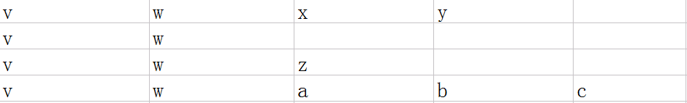
Assume that if v and w coauthored 4 articles,each article has 4,2,3,5 coauthors

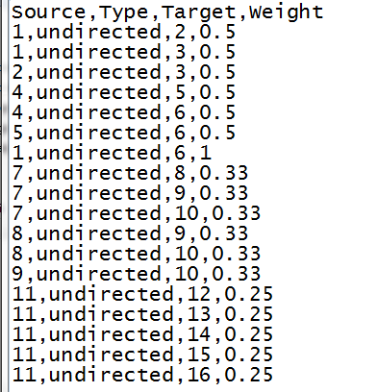
so we set the weight(v,w)=1/3+1/1+1/2+1/4=2.08. As this rule, we can know that the nodes weight degree equals the number of articles this author published.
Base on this rule, I create a dataset input file like this. It has 409 edges and 136 nodes. It a really sparse graph.

Lotka’s Law
Lotka's law[7], named after Alfred J. Lotka, it describes the frequency of publication by authors in any given field. Assume num(n) is the number of authors who published n papers. Then the law is showed as:
Num(1)=60%*TotalNum; Num(2)=1/4*Num(1)
Num(n)=1/(n^2)*Num(1)

Collaboration Network Analysis 6
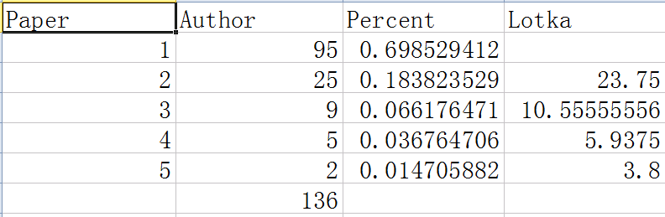
Concern about my own dataset, we calculate and get the result like this:
We can see that even though nowadays the co-authorship is more and more prominent but it still almost obey the Lotka’s Laws.

The analysis for dataset from China
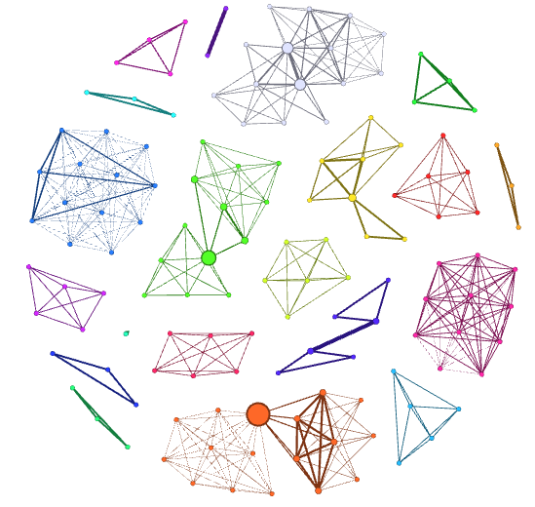
To build the graph, I use the Fruchterman Reingold algorithm to do the nodes separate, color is base on modularity(Community Segmentation), nodes size is based on the betweenness centrality.
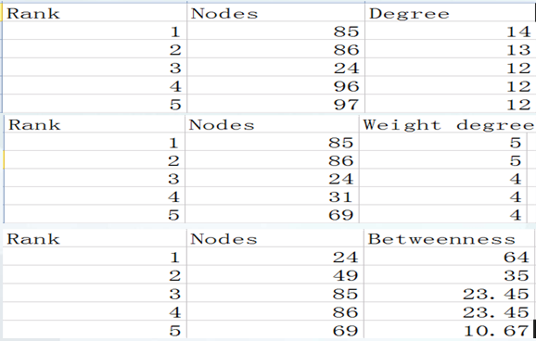
We can see some big nodes in the graph, and we compare with the three kinds of values and make the ranks.

Collaboration Network Analysis 7
The degree rank can show that how many other scientists he used to work with, the weight degree rank can show how many papers a author published, these two rank can show the activity of the authors, and the betweenness centrality rank can show the importance of nodes in the graph, we can see that in first rank 5, nodes 85,86,24 is in all three rank pages. We find the real world information about the 3 nodes.
Node 24: Department head of USTC(university of science and technology China)
Community: other professors in the major and their doctor student
Node 85,86: Two professors from two universities(two schools is in one city)
Community: The major of the two universities(include professors and student)
Also see the betweenness centrality rank 2 node 49
Node 49: A famous professor of Chinese Academy of Sciences
Community: the group of Chinese Academy of Sciences
We can find that the active person and the betweenness centrality can almost show that which one is the leader of a science community, at least is the VIP in the community.
And also, We can find that the Community Segmentation almost show that the real world community.

The analysis for dataset in USA
The USA dataset is download from the Stanford Large Network Dataset and it

Collaboration Network Analysis 8
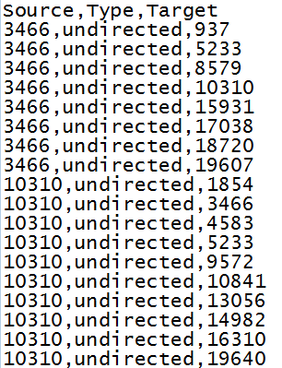
just have the coauthorship between authors but have no weight of edges,the input file is like this:
It has 5242 nodes and 28980 edges, it’s also a really sparse graph.
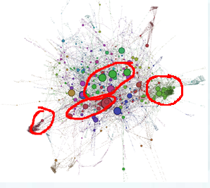
Base on the input we use the same method like we use in Chinese dataset to create the graph like this:
Because the input is really large that we cannot do segmentation really well but we still can find some community like I circled in the graph.
Base on this we can say that the community segmentations in SNA can almost show the real world groups.

Compare and Contrast
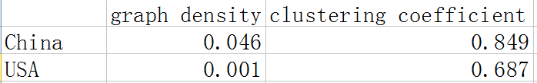
We do the cluster analysis for two different datasets from China and USA, we get some values:

Collaboration Network Analysis 9
Base on these we can find that the cluster effect in the collaboration networks is really notable, that means the authors always work in their own community , they didn't do many communication with other communities. On one hand, it is not good for development of technology, because the development of technology should have more and more communications; but on the other hand, we cannot say the scientists are wrong, because the phenomenon like now can protect the patent rights of their research achievements.
To contrast, we can find that the clustering coefficient in USA is less than China, so the communication in USA is a little bit more than China but still not really much.

Conclusion
Co-authorship is always a really important issue in social network analysis, this research verify the nowadays authors rules is still obey the Lotka’s Law and use betweenness centrality, community segmentation and clustering coefficient to do the co-authorship network analysis.
The betweenness centrality analysis show that the SNA can help us find the active persons and the important person(like leader) in the community, so that we can know that if some new scientist wanna be more and more famous, what he should do is co-work with the person who have high degree in betweenness centrality and it is a easy way to increase the importance of one person in some area.[8]

Collaboration Network Analysis 10
The Community Segmentation can help us to find the real world groups or the cooperation of two groups. It can help us to find the relationship between two different groups, if two groups are in one community, that means maybe they have the same research focus and do many communications, or they always help each others. And also the clustering coefficient analysis show that the USA groups have more communication with other groups than China, but still not really much, each group almost just communicate in their own space. It is no good for development of the subject area.

Outlook
The Chinese dataset is too small and may not be really persuasive to show the conclusions above, the future work is to build a large dataset and to do the social network analysis.
The USA dataset is enough big but have no weight of co-authorship so it just can do the community segmentation, and also, I cannot find the real world information of the authors so cannot compare the important nodes and real world persons.
To solve these problems, I think we can get more reliable and more convincing results.

Collaboration Network Analysis 11
References
[1]Liu Jun, Introduction to Social Network Analysis,2004
[2]Liu X M, Bollen J, Nelson M L, et al. Co- authorship networks in the digital library research community,2005
[3]Yin Guopeng,Mo Yunsheng,Chen Yu, Promoting tacit knowledge management using social network analysis,2006
[4]Learner Ooof,Gephi tutorial courses,http://www.udemy.com/gephi/
[5]Jure Leskovec, Stanford Large Network Dataset Collection,
http://snap.stanford.edu/data/
[6]China National Knowledge Infrastructure,http://www.cnki.net/
[7]Alfred J. Lotka, Lotka's law,http://en.wikipedia.org/wiki/Lotka%27s_law
[8]BURKS R L,CHUMCHAL M M.To co-author or not to co-author:how to write,publish,and negotiate issues of authorship with undergraduate research students.2009

